Nombres Sumériens
Learn to Read Ancient Sumerian – Volume Two
(1 Pack)
MémoCartes Sumérien 08.12.2025
http://www.mementoslangues.fr/

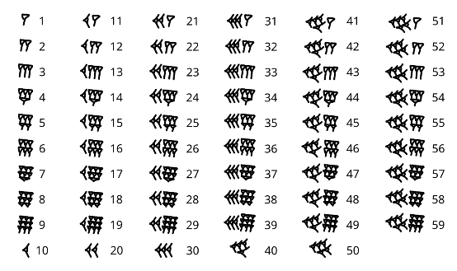

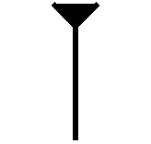 | 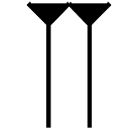
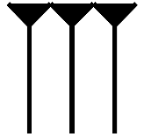 | 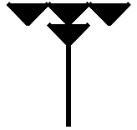

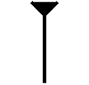 | 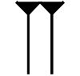
diš | min
1 | 2
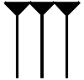 | 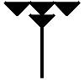
eš | limmu
3 | 4

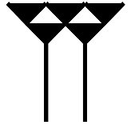 | 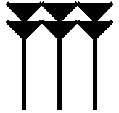
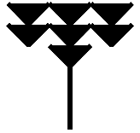 | 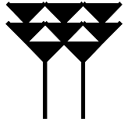

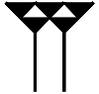 | 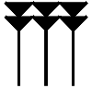
ia | aš
5 | 6
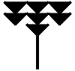 | 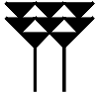
imin | ussu
7 | 8

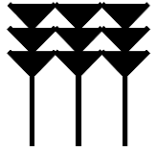 | 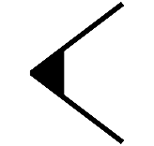

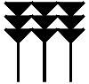 | 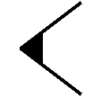
ilimmu | u
9 | 10
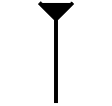 | 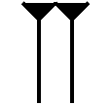
u-diš | u-min
11 | 12

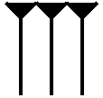 | 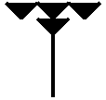
u-eš | u-limmu
13 | 14
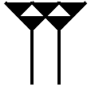 | 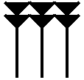
u-ia | u-aš
15 | 16

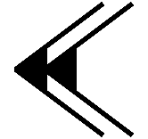

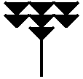 | 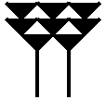
u-immin | u-ussu
17 | 18
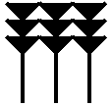 | 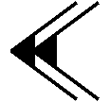
u-ilimmu | niš
19 | 20

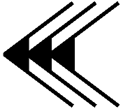 | 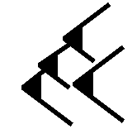
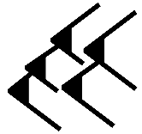

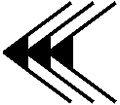 | 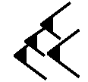
ušu | nimin
30 | 40
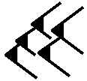
ninnu | g̃eš
50 | 60 (60x1)

g̃eš-u | g̃eš-niš
70 | 80
g̃eš-ušu | g̃eš-nimin
90 | 100

g̃eš-ninnu | g̃eš-min
110 | 120 (60x2)
g̃eš-min-u | g̃eš-min-niš
130 | 140

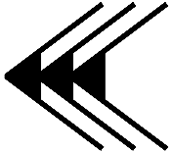

g̃eš-min-ušu | g̃eš-min-nimin
150 | 160
g̃eš-min-ninnu | g̃eš-eš
170 | 180 (60x3)

g̃eš-eš-u | g̃eš-eš-niš
190 | 200
g̃eš-eš-ušu | g̃eš-eš-nimin
210 | 220

g̃eš-eš-ninnu | g̃eš-limmu
230 | 240 (60x4)
g̃eš-ia | g̃eš-aš
300 (60x5) | 360 (60x6)

