**Dipper, Sword, Snake and Turtle**

Four constellations as indicators for the ecliptic pole in ancient China?

Stefan Maeder (PhD, M.A.)

Kokugakuin University Tokyo

Email: [sjdmaeder@aol.com](mailto:sjdmaeder@aol.com)

Keywords: Archaeoastronomy – ecliptic-pole – Chinese constellations – Big Dipper

Abstract:

The findings outlined in the following article occurred in the course of an international archaeological survey focusing on early representations and accounts of the “Big Dipper”-asterism in *Ursa Major*. They encompass the tentative identification of three ancient Chinese constellations, namely the sword, the snake and the turtle, which –together with the “Big Dipper” - surround the pole of the ecliptic at even distances to each other and to the pole itself. In fact they form a cross-shape with the ecliptic pole at its center. The sword-constellation consists of the central stars of *Cygnus* (without the outer “wing”-stars). The snake-constellation contains *Corona Borealis* as the distinct central coil, the four northern stars of *Hercules* as its head and the three northern stars of *Bootes* as its tail. The head, shell and tail of the turtle-constellation are accurately matched by the six major stars of *Cassiopeia*, the feet by two stars immediately south of the celestial “W”-shape. These representations are found on charm/amulet coins whose obverse script is based on currency coins first issued by the later Han-period (206 B.C. – 220 A.D.) without the symbols on the back. Whether the symbols on the reverse side of the coins were added already contemporary with their use as currency or later is as yet an unsettled matter. The representations are all rendered mirror inverted including the angle towards each other and towards the center of the coin. They point towards an independent undercurrent in Chinese astronomy/astrology during the first centuries A.D. which may provide a new impulse for research into the history of art and religion not only in China itself, but also in the countries influenced by its cultural achievements.

1. Introduction:

After more than 100 years of archaeo-astronomical studies it is still an exception that an archaeologist should write on a subject, which - when viewed superficially - is apparently not connected to the “science of the spade” at all. However, in view of the combined results of archaeological and astronomical research obtained during the preceding decades it is even more puzzling that the majority of archaeologists and astronomers still remains unfamiliar with even the most basic terms and principles of their respective disciplines[1]. Without this basic understanding it is a petty feat indeed to dismiss evidence pointing towards archaeo-astronomical contexts as a kind of wishful thinking. Thus I hope that the outline of a few basics for skeptical archaeologists will be excused by readers well acquainted with astronomy. To be able to judge the significance of the findings presented in this paper a whatsoever rudimentary understanding of the term “precession” is indispensable. For those unfamiliar with the term a concise definition of the precessional cycle is rendered here[2] **(fig. 1)**.

*“In* [*astronomy*](http://en.wikipedia.org/wiki/Astronomy)*, axial precession is a gravity-induced, slow and continuous change in the orientation of an astronomical body's rotational axis. In particular, it refers to the gradual shift in the orientation of* [*Earth*](http://en.wikipedia.org/wiki/Earth)*'s axis of rotation, which, like a wobbling top, traces out a* [*cone*](http://en.wikipedia.org/wiki/Cone_(geometry)) *in a cycle of approximately 26,000 years. The term "precession" typically refers only to this largest* [*secular motion*](http://en.wikipedia.org/wiki/Secular_phenomena)*; other changes in the alignment of Earth's axis —* [*nutation*](http://en.wikipedia.org/wiki/Nutation) *and* [*polar motion*](http://en.wikipedia.org/wiki/Polar_motion) *— are much smaller in magnitude.”*

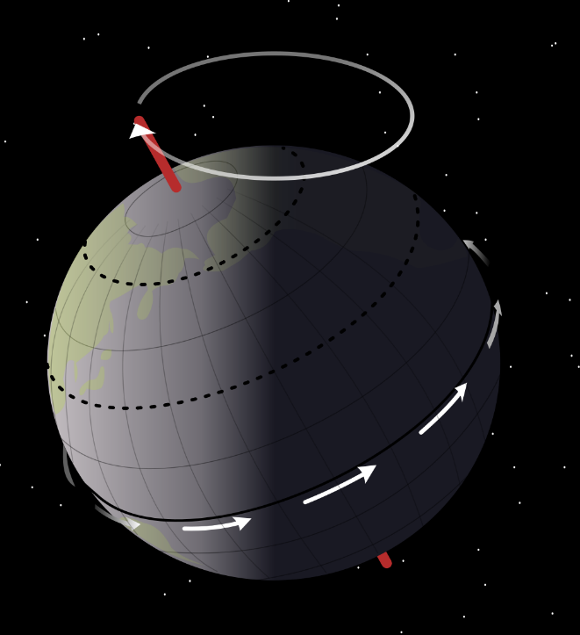

Fig. 1: The precession of the earth´s axis in a timespan of roughly 25920 years traces a circle, the center of which is the pole of the ecliptic. The earth´s central axis, pointing to the equatorial pole, stands perpendicular to the equatorial plain (source: Wikipedia, NASA).

One consequence of this phenomenon is that there are actually two celestial north poles and two celestial south-poles. There is not only the pole of the earth´s axis - the pole of the equatorial plain -, but also the center of the precessional circle outlined by the earth´s axis in the course of about 25920 years: the pole of the ecliptic **(fig. 2)**. The latter appears indeed as “immovable”. The pole of the earth´s equatorial plain can be determined after a few nights of attentive observation even without the aid of the “Big Dipper”- asterism. The present *Polaris* is α-*ursa minoris*, the last star of the little bear´s tail. Also due to the phenomenon of precession there are millenia without an actual star close to the equatorial north-pole. Actually it is a rare occurrence that the direction of the earth´s axis points towards one of the visible stars at all. Comparable to our present Polaris, during the centuries around 2800 B.C. the less bright *Thuban* (α-*draconis*) was the pole-star. Concerning the eminent role of the celestial pole and the potential meaning of precession in Chinese astronomy the following was stressed by J. Needham[3]:

*„It is therefore a fact of the greatest interest that we find, along the whole length of the path which it has transversed since that date* (3000 B.C., note by the present author)*, stars which have preserved Chinese names indicating that they were at various times pole-stars, but later ceased to be so.”*

Recently J. Magli in a chapter titled „the discovery of precession before the discovery of precession”[4] remarked that *it is virtually impossible for one single person to discover the precession of the earth´s axis by means of observations, even over many decades, as the phenomenon changes far too gradually. Nevertheless, it is sufficient to have precise information, for example, regarding the position of the heliacal rising of a star over the space of 200 or 300 years, or the position of the equinoctial point over an analogous period of time, to notice that* something is happening: *the shifting of the rising point of the star, or the fact that the sun is rising against a background of different stars.*

The most convincing evidence hitherto for the notion and eventual understanding of precession in ancient Mesopotamia was provided by A. Bond and M. Hempsell in 2008[5]. Depending on the validity conceded to prehistoric clues ranging from the European Paleolithic to the Ages of Bronze and Iron it can be assumed that in cultures with a continuous tradition of night-sky observation, a star´s apparent approach to, arrival at and departing from the apparent center of the motion of the firmament/cosmos/universe had a certain impact also on the non-star-gazing parts of the different communities to put it soberly. As a matter of fact there is hardly any culture whether examined by archaeology or ethnography which displays no astronomical elements within its belief-systems.

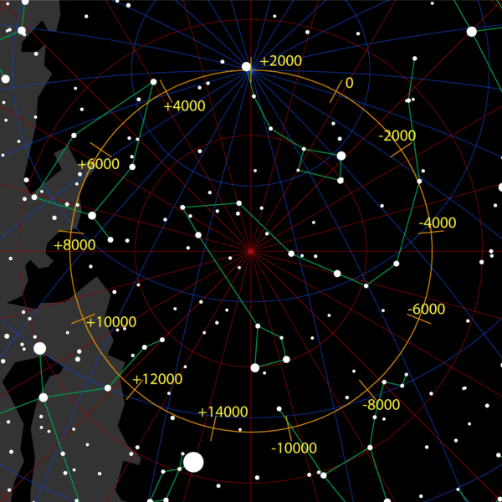

Fig. 2: Schematic rendering of the precessional cycle with the pole of the ecliptic in the center, surrounded by the upper part of the *Draco*-constellation . It is obvious that it is a rare occurrence to have an actual pole-star which is close to the circle described by the earth´s axis and bright enough to be seen (source: Wikipedia, Tau´olunga).

In contrast to locating the equatorial pole and noticing the phenomenon of precession it would take around 2000 years of systematic observation at the very least and a well developed sense of abstraction to recognize that the succession of former stars and empty spaces, which over time represented the equatorial pole traces the outline of a circle. Consequently deducing that the apparent motion of the equatorial pole describes a complete circle with an unchanging center would be a respectable scientific feat, or perhaps even more admirable, a highly educated guess. Of course the ecliptic plain marking the sun´s apparent course across the sky was well known and divided into sections in ancient Mesopotamia and Egypt, but when it came to representing the center of the sky, it was always the equatorial pole that was rendered. In any case one has to be aware that such observations did not arise from academic or scientific interest in a modern sense, but were tightly linked to cosmological and religious concepts extant not only in prehistoric and early historic Mesopotamia and China. This is why many constellations, planets, the sun and moon were represented by different symbols which had their roots in the respective mythologies of ancient civilizations. Thus it is inappropriate – as is done by some authorities nowadays - to presume that different cultures would necessarily arrive at the Greek/Roman standards when likening groups of stars to certain familiar shapes. E.g. for an astronomer well-versed in the identification of classical constellations it may be hard to acknowledge early Chinese and Korean representations of the night-sky as star-charts at all. In this context it is necessary to mention the fact that even at present the constellations on different star-charts are not standardized. One of many examples is the circumstance that the Big Dipper-asterism has traditionally been viewed as the backside and tail of *Ursa Major*, but is represented as the head of the bear in some modern star-maps.

2. The coin and the pole:

In 2010 the author obtained a Chinese coin-charm of *Yung T´ung Wan Kuo*-type (“the everlasting currency of the empire”) which originally was issued during the reign of emperor Hsüan (578-580 A.D.) and has been recast since that time **(fig. 3a,b)**. The round coin is cast from bronze, 1 mm thick and has a diameter of 2,35 cm. In the middle there is a square opening of 8 x 8 mm side-length with a raised rim.

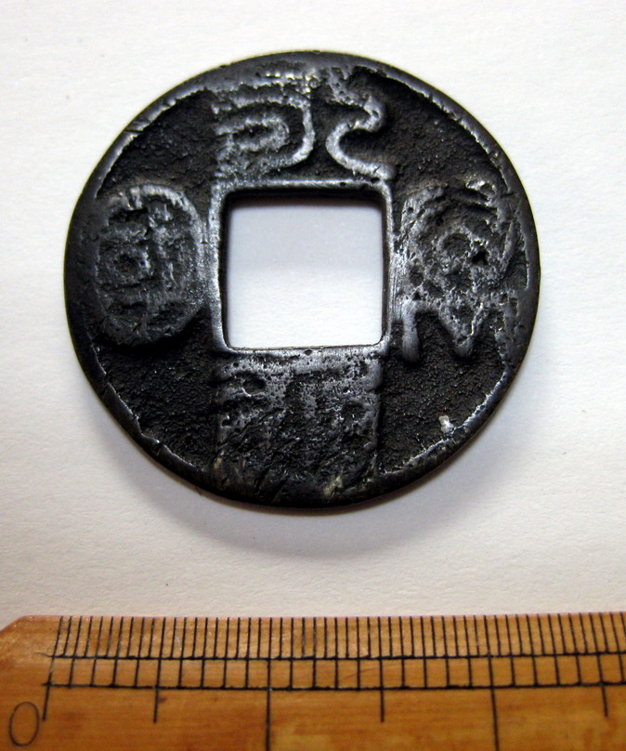

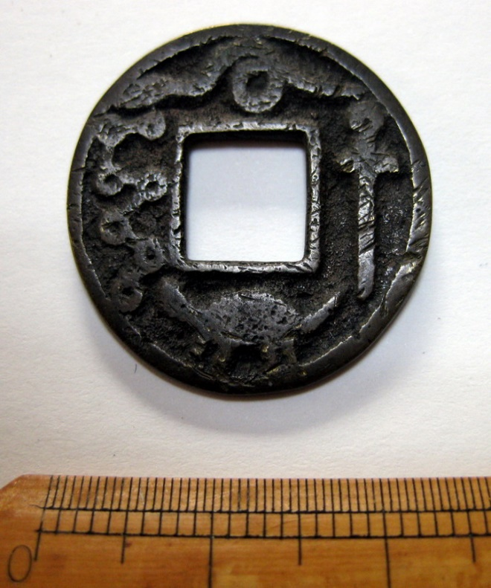

Fig. 3a, b: Chinese Bronze coin of *Yung T´ung Wan Kuo*-type, showing the four characters on the obverse side and the mirror-inverted “big dipper”, sword, snake and turtle on the reverse side.

Among the constellations surrounding the equatorial pole of the northern hemisphere the “Big Dipper” is the easiest to identify. Thus it always served and in some parts of the world still serves as a night-time clock, an indicator of seasonal change and as a means to locate the equatorial pole represented by α-*ursa minoris* at present. The “Big Dipper” served as a pointer towards the equatorial pole at least since the fourth millennium B.C.. However it was not thought of that it could also be used to locate the “starless” pole of the ecliptic together with three other constellations in ancient China. For the following it is important to keep in mind the fact that the obvious constellation of the Big Dipper is represented mirror-inverted on the coin. On the basis of the outlined facts it was decided to check whether the other representations – sword, snake and turtle - might eventually represent constellations also by putting the coin on a celestial map. This combination of the Big Dipper together with the other symbols occurs in the same and other combinations on Chinese charm coins until the 20th century. However, in view of the congruency of the symbols with actual constellations it is argued here that this combination probably represents the oldest version, eventually reaching back into Han-times.

From the arrangement of the four symbols on a round coin with a square central opening, it was not difficult to deduce that this kind of charm is just another way to express the Chinese cosmological concept of heaven, earth and center. The roundness of the coin together with the “big dipper”, sword, snake and turtle representing heaven and the square opening in the middle representing the terrestrial sphere opening towards the center of the sky. In fact the option that the square represents a kind of window for a divine spectator of earthly affairs should not be dismissed too hastily either, as the pole was considered the “highest” place in the sky and the abode of the supreme deity in several ancient cultures. Such an interpretation may appear fanciful in the eyes of researchers solely concerned with categorization of ancient material evidence or present issues of astronomy. Nonetheless, the tradition of correlative thought[6] in ancient China can unmistakably be traced by written sources to at least the middle of the 2nd century B.C.. This is vividly depicted in the 7th chapter of the Han-era compendium *Huai-nan-tzu* (ca. 139 B.C.)[7]:

*“Therefore the head´s roundness resembles heaven and the feet´s squareness resembles earth. Heaven has four seasons, five phases, nine sections, and 366 days. Man likewise has four limbs, five viscera, nine orifices, and 366 joints. Heaven has wind and rain, cold and heat. Man likewise has taking and giving, joy and anger. Thus the gall bladder is cloudy, the lungs are pneumatic, the liver is windy, the kidneys are rainy, and the spleen is thunderous. (These organs) correspond with heaven and earth, and yet the heart serves as the sovereign (of all). Thus the eyes and ears are the sun and the moon; and the blood and pneuma are the wind and rain.”*

This manner of linking heaven and man, macrocosm and microcosm, was by no means limited to ancient China, but is extant in a variety of pre-christian writings, representative examples being Platon´s (427/428 – 348/347 B.C.) cosmological treatise *Timaios[8]*, the *Corpus Hermeticum,* the Scandinavian *Edda* and other strands of Greek, Roman, Celtic, Germanic, Korean and Japanese tradition. The heaven-related passages in early Japanese mythology reflect this principle as clearly as the orientation and astronomical “decoration” of tumuli, shrines, temples and the layout of early capitals in Babylonia, China and Japan. It is commonplace to note that the earliest surviving written fixation of any myth is not necessarily identical with its initial formation. In prehistoric contexts in general most finds of a “ritual” kind point towards the same kind of correlative thought which appears to have been a constituent factor of the human mind right from its beginnings. Many examples are found in the bible also, but in context with an immovable celestial pole as the final abode of the human soul a poem by Hildebert of Lavardin (1056-1133), the bishop of Le Mans and later archbishop of Tours (France), from the 11th century provides the most compelling evidence:

*Threefold is the abode of the just,*

*In the open air the first,*

*In the second he lies under the earth,*

*Above the stars stands the following,*

*The house as the habitation here,*

*The grave as the habitation here,*

*The pole as the abode there,*

*The first deteriorates, the second decays,*

*The third lasts (eternally).(…)*

Another much earlier historical and philosophical pointer largely ignored by archaeologists and astronomers alike is provided in Platon´s *Timaios[9]*:

*„Having mixed all this together, he partitioned souls in the same number as stars and allotted to each star one soul. Then he put them in a kind of wagon, showed to them the principle of the cosmos and revealed to them the laws imposed by fate; (…) and he who has lived well in the space of time allotted to him shall return to the abode in his star and live a happy life appropriate to him.”*

The belief in a soul´s journey to the stars in general and to the apparent center and eventual origin of the universe, i. e. the celestial pole, in particular was extant in different ancient cultures including China, Korea and Japan. That a corresponding notion existed in medieval Europe cannot only be deduced from the aforementioned texts, but also from the description of Paradise in Dante´s “Divine Comedy”, which depicts a journey of the soul through the seven planetary spheres up to the highest region, the center of heaven. This journey described in a medieval Christian context has forerunners in the Roman Mithraic cult originating in ancient Persia and in the hermetic teachings said to have originated in Egypt. These important early sources for the comparative history of religion in relation to astronomy are widely available nowadays and as a matter of fact have nothing whatsoever to do with more recent esoteric fancies.

Keeping in mind that ancient Chinese astronomy is based on the equatorial system I decided to check if - in view of the unmistakable representation of the Big Dipper - the other representations on the coin might eventually correspond to the outlines of constellations also. So the center of the coin was put above the present Polaris (*α-Ursa Minoris*) and other areas of the sky which housed the celestial pole during the last 2000 years. The mirror-inverted big dipper was oriented to its correspondent on the map. Yet, apart from the big dipper, none of the constellations at about the same distance from the pole as the Big Dipper resembled the outline of the other objects depicted on the coin **(fig. 4)**.

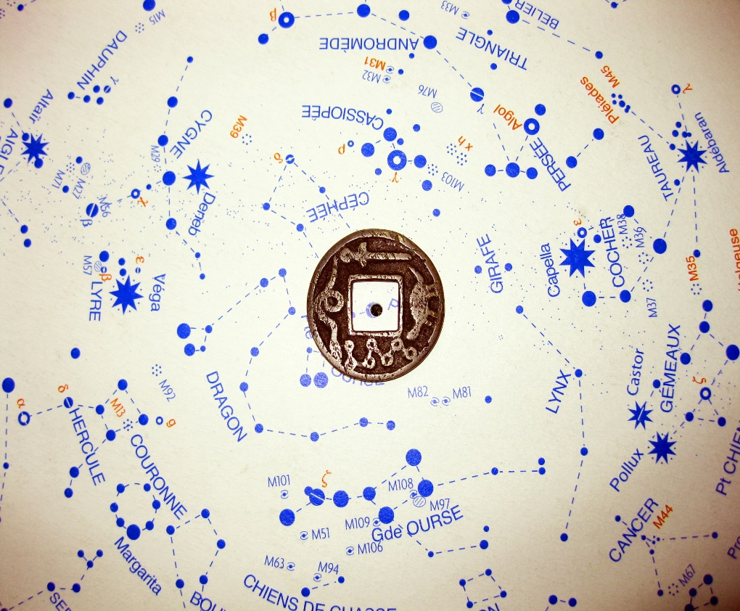

Fig. 4: The coin aligned with the present Polaris *(α-ursa minoris)*. The mirror-inverted representation of the Big Dipper is oriented according to its correspondent, including its mirrored angle.

It was then that I decided to try the same for the pole of the ecliptic. The result was as follows **(fig. 5)**. When aligning the mirror-inverted representation of the Big Dipper on the bronze-coin with the original on the star-map, incorporating its mirrored angle towards the pole of the ecliptic, the constellation of the swan (*cygnus*) is on the opposite side at about the same distance as the Big Dipper.

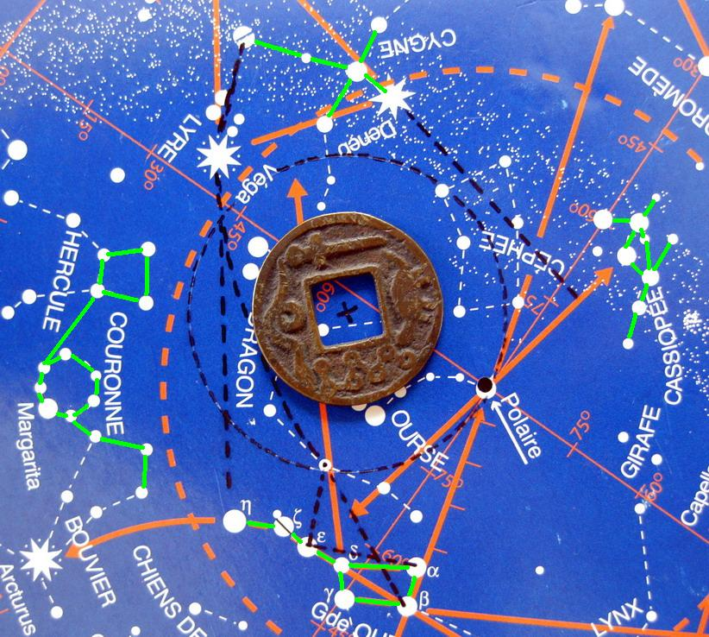

Fig. 5: The center of the coin placed above the pole of the ecliptic, again including the mirrored angle of the Big Dipper and *Cygnus*.

The central and brightest stars of the *Cygnus*-constellation **(fig. 6)** form a characteristic cross-shape. As was also the case with European swords from medieval times the sword on the Chinese coin was likened to a cross-shape by elongating the cross-guard and incorporating a so-called wheel-pommel.

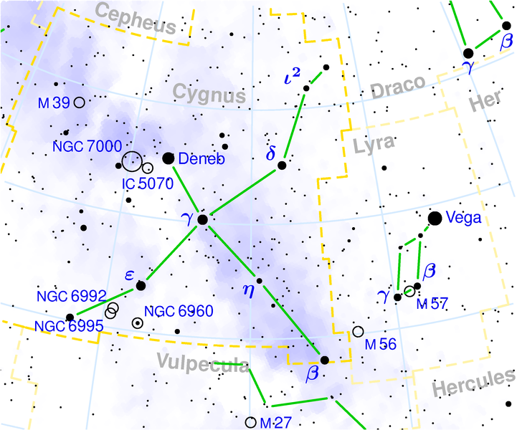

Fig. 6: The central stars of the swan-constellation form a characteristic cross-shape, which corresponds to the sword-shape on the 6th-century coin with Deneb, the brightest star representing the pommel (source: Wikipedia, © Torsten Bronger, 2003).

In the interpretation of the constellation´s outline, *Deneb*, the brightest star, is viewed as the sword´s round pommel, with γ (*gamma*), η (*eta*), β (*beta*) representing the blade, and ε (*epsilon*), γ (*gamma*), δ (*delta*) forming the cross-guard of the sword. Referring now to fig. 5 above it is obvious that the sword-representation on the coin, when mirror-inverted, corresponds to the outline of *cygnus* to a degree that even the angle towards the ecliptic pole and the big-dipper-asterism on the opposite side is rendered accurately.

Applying a proper degree of scepticism, this could still be viewed as a kind of coincidence. Progressing now to the snake-representation on the coin, its most conspicious feature is the central coil. Thus I started looking for a similar alignment of stars at about the same distance from the pole of the ecliptic and situated at an angle of about 90 degrees between *Cygnus* and the big-dipper. When viewing fig. 5 it is easy to recognize the characteristic circle of stars forming the northern crown, *corona borealis*. The northern crown is flanked by *Hercules* **(fig. 7)**and *Bootes* **(fig. 8)**. Viewing *corona borealis* as the coil, the torso of *Hercules* as the head (a corresponding view likens the lozenge of stars at one end of *draco* to the head of the dragon) and the head and shoulders of *Bootes* as the tail of the snake, the resemblance is striking to the degree that the representation is unmistakably mirror-inverted again.

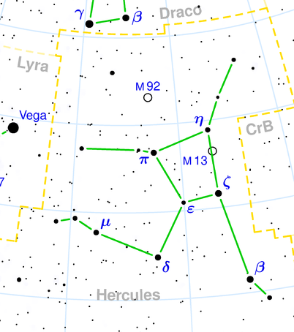

Fig. 7: The torso of the Greek *Hercules*-constellation outlined by the stars η(*eta*), ζ (*zeta*), ε (*epsilon*), and π (*pi*) forming the head of the Chinese snake-constellation (source: Wikipedia, © Torsten Bronger, 2003).

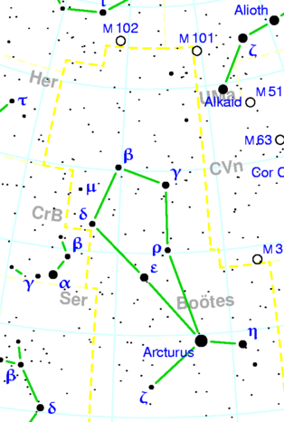

Fig. 8: The constellation *Bootes*. The stars δ (delta), β (beta), and γ (gamma) form the tail of the Chinese snake-constellation (source: Wikipedia, © Torsten Bronger, 2003).

When comparing the last of the representations rendered on “the everlasting currency of the empire” to a modern star-map, the option of a mere coincidence is minimized. Again being situated at about the same distance from the pole of the ecliptic and at an angle of ca. 90 degrees between the big-dipper and the sword, the turtle obviously represents the constellation of *Cassiopeia* **(fig. 9)**.

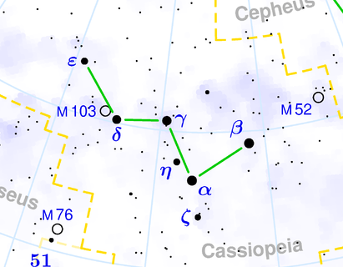

Fig. 9: The Greek constellation of *Cassiopeia* forming the outline of a turtle with β (*beta*) as its head and ε (*epsilon*) as its tail. β (*beta*), the brightest star stands for the head, α (*alpha*),γ (*gamma*),δ(*delta*) form the shell, ε marks the end of the tail. ζ(*zeta*) represents one foreleg, another more inconspicuous star marks one hind leg. Again, in line with the three other representations on the coin, the heavenly turtle is depicted mirror-inverted.

1. Conclusions:

Incorporating the results of comparative studies relating to the history of myths and religions in relation to astrology and astronomy it was argued that the symbol-combination on the reverse side of a charm-coin of *Yung T´ung Wan Kuo-*type represents three hitherto unidentified early Chinese constellations. They surround the pole of the ecliptic together with the Big Dipper-asterism. The position of the snake on the upper, “northern” section of the coin in relation to the turtle on the lower, “southern” section allows for an interpretation as a North-South-Axis. This interpretation is supported by the fusion of snake and turtle (玄武=Genbu in Japanese) as representing north in funerary wall-paintings from the 5th to 8th centuries A.D. from China, Korea and Japan. Furthermore this circumstance points towards a higher antiquity for the symbolism rendered on the coin in relation to the well-known Chinese, Korean and later Japanese practice of representing north by the “black warrior” (turtle combined with snake), south by the “red *Fenghuang*-bird” (“*phoenix*”), east by the “azure dragon” and west by the “white tiger”. Other pointers towards the relevance of the ecliptic pole in Chinese cosmological concepts include dragon representations on the reverse side of Tang-period (618-907 A.D.) mirrors. There the dragon closely resembles the constellation of *Draco* and the central knob is located at the spot corresponding to the pole of the ecliptic. The exact dating of the earliest Chinese charm coins still poses some problems and as yet there is no comprehensive study on this matter available in English. Still there are excavated examples which can be safely dated to the 2nd century A.D.. The implications of the findings outlined above are relevant not only for studies in the history of astronomy, but may prove fruitful also for archaeological and numismatical studies in general. However, the present concise outline is intended as a preliminary report and a small contribution to the discussion of early Chinese astronomical symbolism. It will be expanded and further illustrated in a future publication.

Literature:

Hildebert von Lavardin: Bourassé, J.J. (Hrsg.): Venerabilis Hildeberti Primo Cenomanensis Episcopi Deinde Turonensis Archiepiscopi Opera Omnia Tam Edita quam Inedita (Tours 1854).

Bond, A./Hempsell, M., 2008: A Sumerian Observation of the Köfels Impact Event (Alcuin Academics 2008)

Cornelius, G./Devereux, P.: The Language of Stars and Planets (London 2002).

Grundmann, H., 2003: Amulette Chinas und seiner Nachbarländer (Pirmasens 2003).

Henderson, J.B.: The Development and Decline of Chinese Cosmology (New York 1984)

Henderson, J.B.: The Development and Decline of Chinese Cosmology (New York 1984).

Magli, J.: Mysteries and Discoveries of Archaeoastronomy – From Giza to Easter Island (New York 2009).

Needham, J.: Science and Civilization in China, Vol. 3, Mathematics and the Sciences of the Heavens and the Earth (Cambridge 1959).

Platon: Paulsen, Th./Rehn, R. (Eds.): Platon – Timaios (Stuttgart 2003).

Kelley, D.H./Milone, E.F.: Exploring Ancient Skies – An Encyclopedic Survey of Archaeoastronomy (New York 2005).

1. An easy to understand and well illustrated introduction to the basics of astronomy in connection with cultural history was provided by Cornelius/Devereux, 1996.
2. <http://en.wikipedia.org/wiki/Axial_precession_(astronomy)>
3. Needham 1959, 259.
4. Magli, 2009, 277-278.
5. Bond/Hempsell, 2008, 5, 43-48, fig. 13.
6. Henderson, 1984, 1-58.
7. Huai-nan-tzu 7.2a, cited from Henderson, 1984, 3.
8. Platon, ed. Paulsen/Rehn 2003.
9. Platon, ed. Paulsen/Rehn 2003, 67, 69.